**NANDHA ENGINEERING COLLEGE**

**(Autonomous Institution)**

Erode-638 052



**TABLEAU-TWO CREDIT COURSE**

**IV – Semester**

**B.Tech - Artificial Intelligence and Data Science**

**NAME : R.S.JANANI**

**REG.NO : 23AI024**

**BRANCH : B.TECH AI & DS**

**YEAR : II**

**TABLEAU**

* Tableau is a data visualization tool.
* Used for analyzing and visualizing data through interactive dashboards and reports.
* Allows easy creation of charts, graphs, and maps.
* Connects to various data sources (Excel, databases, cloud services).
* Helps in identifying trends, patterns, and outliers in data.
* Known for a user-friendly, drag-and-drop interface.
* Supports real-time data analysis and updates.
* Popular in business intelligence and data analysis fields.
* Can be used for both individual and collaborative data analysis.

**OVERVIEW OF THE PROJECT**

The goal of this project is to analyze accident data collected from Nashville (Jan 2018 – Apr 2025) to uncover insights about accident trends, major contributing factors, and risk-prone areas. The final output helps in understanding where and under what conditions accidents are most frequent.

**ACCIDENT ANALYSIS REPORT (Jan 2018 – Apr 2025)**

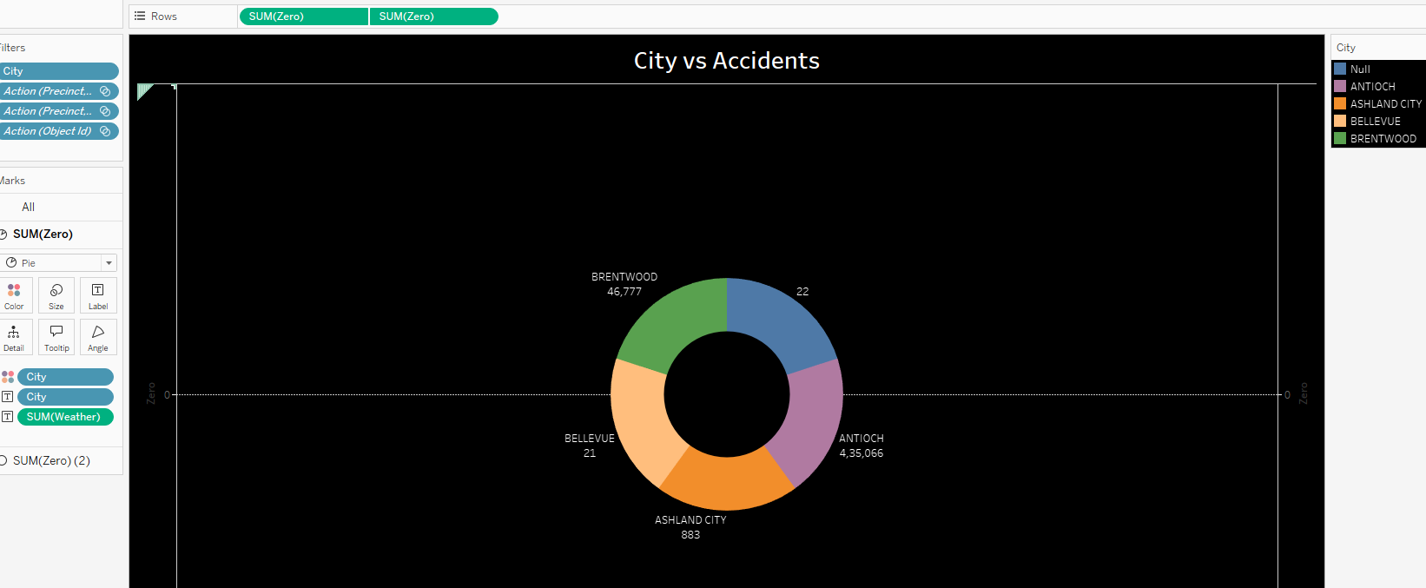

* The visualization represents a donut chart titled "City vs Accidents", created using Tableau.
* In the Columns shelf, SUM(Zero) is added twice to manage the chart's alignment, while no fields are placed in the Rows shelf

.

* The Filters section includes City, Action (Precinct...) (two instances), and Action (Object Id) to narrow down the data.
* The chart uses City for colour differentiation, and accident counts are displayed as labels on each segment.

* The analysis shows that Antioch has the highest number of accidents (435,066), followed by other cities like Brentwood, Ashland City, and Bellevue with significantly lower numbers.

* A Null category is also visible, indicating possible missing city data that may require cleaning. The black background enhances the visual clarity of the chart.

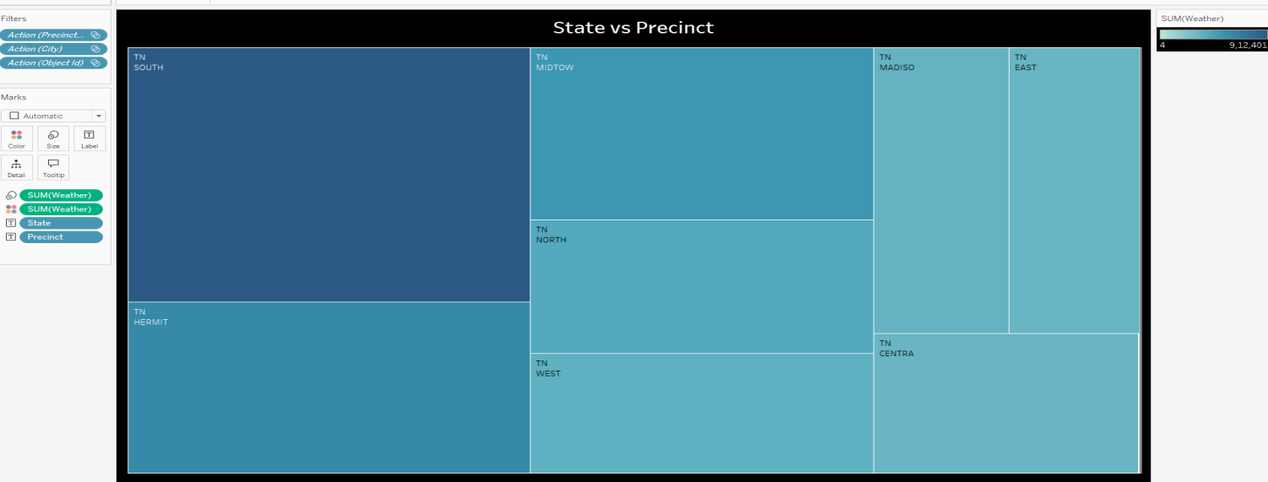

* The visualization titled **"State vs Precinct"** is a **tree map chart** created using **Tableau**.
* In this chart, each block represents a different precinct within the state of Tennessee (TN), sized according to the **SUM(Weather)** measure.

* The Columns shelf includes **SUM(Weather)** twice, while no fields are placed in the Rows shelf.

* The Filters applied are **Action (Precinct)**, **Action (City)**, and **Action (Object Id)**, which allow users to refine the displayed data.

* The **Marks** card is set to Automatic, and the fields **State** and **Precinct** are used to define the structure of the tree map.

* The color intensity indicates the volume of the **Weather** measure, with darker shades representing higher values.
* From the tree map, it is observed that the **SOUTH precinct** has the largest area, indicating the highest recorded weather-related activity, followed by MIDTOW, HERMIT, and others

.

* The black background enhances the visual contrast, making the chart easy to interpret.

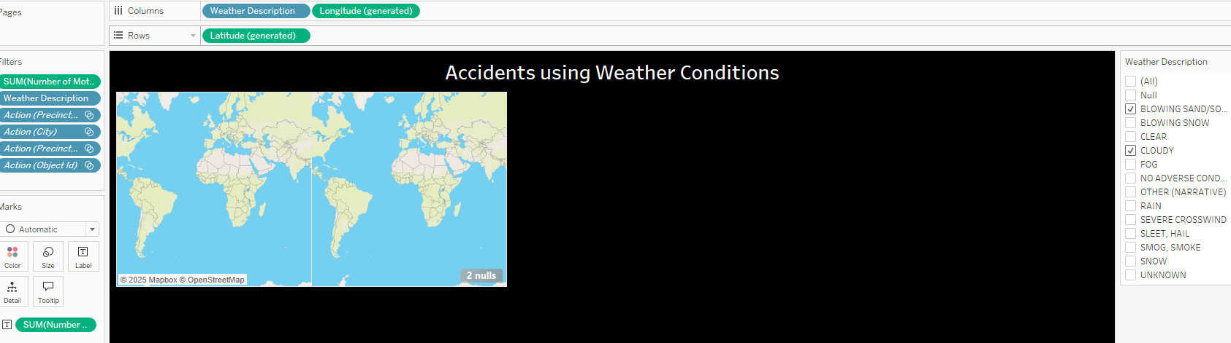

The visualization titled **"Accidents using Weather Conditions"** displays accident data on a **world map** based on **weather conditions**.

* The Columns shelf contains **Weather Description** and **Longitude (generated)**, while the Rows shelf includes **Latitude (generated)**.
* Filters applied are **SUM (Number of Motor Accidents)**, **Weather Description**, **Action (Precinct)**, **Action (City)**, and **Action (Object Id)**.
* The **Marks** card is set to Automatic to plot data points geographically.
* The map shows accidents occurring under specific weather conditions like **Blowing Sand/Soil** and **Cloudy**, with data points plotted based on accident locations. Two null points indicate missing or incomplete location data.
* The black background helps highlight the map and selected filters clear.

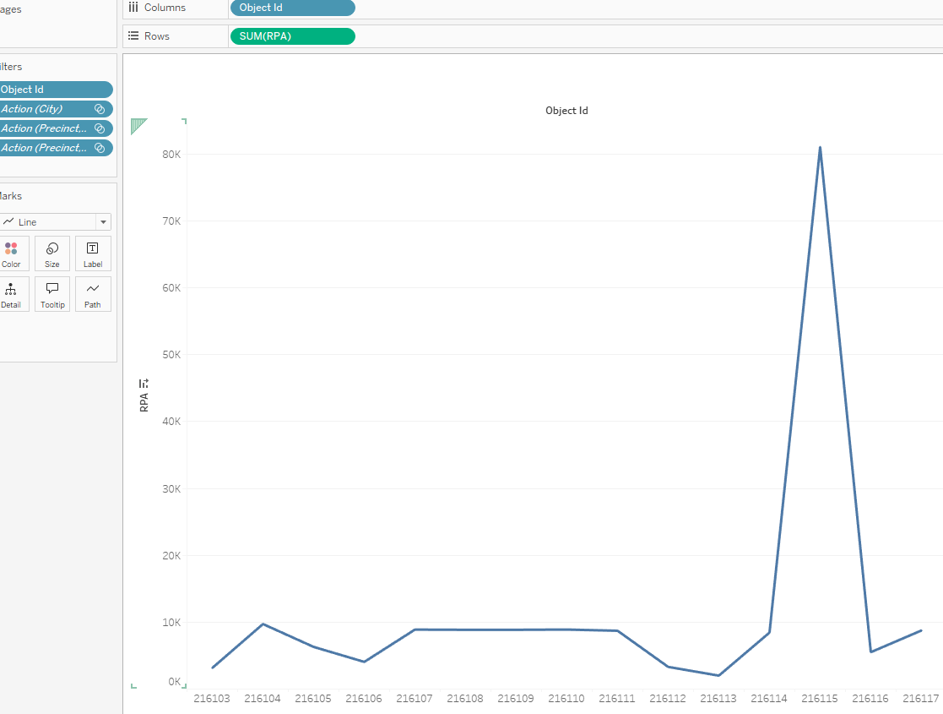

* The line chart represents the **sum of RPA values** mapped against various **Object IDs**.
* Most Object IDs show relatively **low and steady** RPA values, typically remaining under **10K**.

* However, there is a **sharp and significant spike** at **Object ID 216115**, where the RPA value peaks dramatically above **80K**.
* After this peak, the values quickly drop back to normal levels. Filters such as **City**, **Precinct**, and **Object ID** have been used to narrow down the data, ensuring a focused analysis.
* The **Line** mark type effectively highlights the sudden changes and trends across different Object IDs, helping to easily identify anomalies or patterns in the dataset.

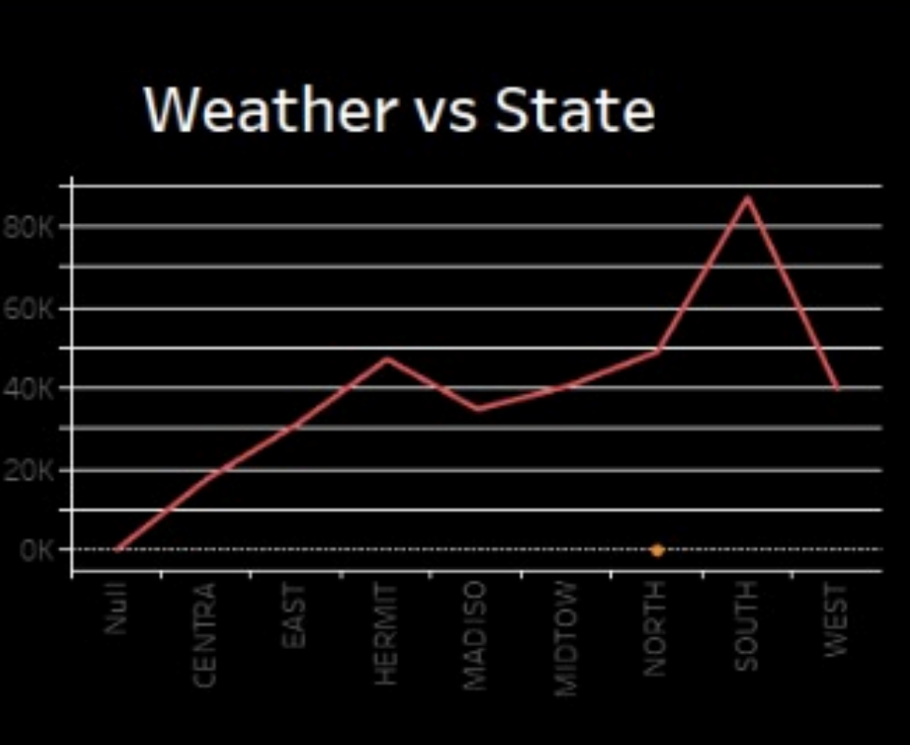

* The "Weather vs State" visualization presents a line graph analyzing accident frequency across various states under clear weather conditions.
* The trend clearly shows that the 'SOUTH' region experiences a significantly higher number of accidents compared to other states, even in favorable weather.
* 'HSMAT' follows but at a much lower count. 'EAST' and 'MADHYA' report moderate accident levels, whereas 'FAR', 'CENTRA', 'NORTH', and 'WEST' exhibit relatively low and similar accident numbers.
* This stark contrast suggests that weather alone does not account for accident rates, and localized factors in 'SOUTH' — such as heavy traffic, higher population density, road infrastructure quality, or driver behavior — may play a major role.
* These findings highlight the need for a focused investigation and targeted interventions to enhance road safety in the 'SOUTH' state.

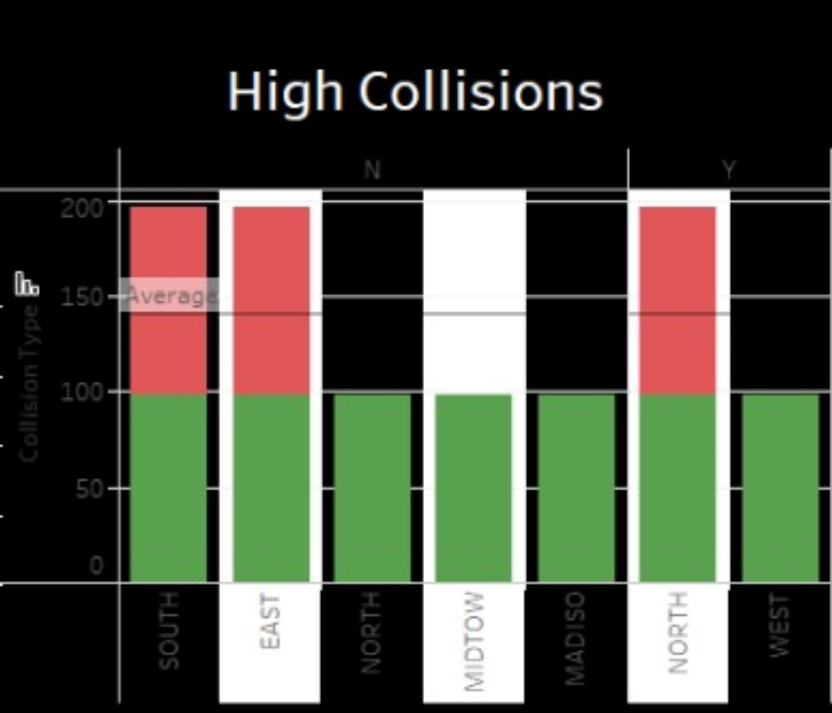

* This chart visualizes data across different directions: South, East, West, NW/SW, NE/SE, North, and NW/NE. For each of these directions, there are two stacked bars: a shorter green bar at the bottom and a taller red bar stacked on top.
* The height of each bar represents a certain value, as indicated by the y-axis which ranges from 0 to 160.

* It appears the red portion of the bars is consistently larger than the green portion across all directions, suggesting a higher count or magnitude for whatever the red category represents compared to the green category.
* Notably, the combined height of the bars for the "NW/SW" and "NE/SE" directions is significantly lower than in other directions, indicating fewer collisions in these combined quadrants.
* However, the visual representation clearly highlights the relative differences in these two categories across the various directions.

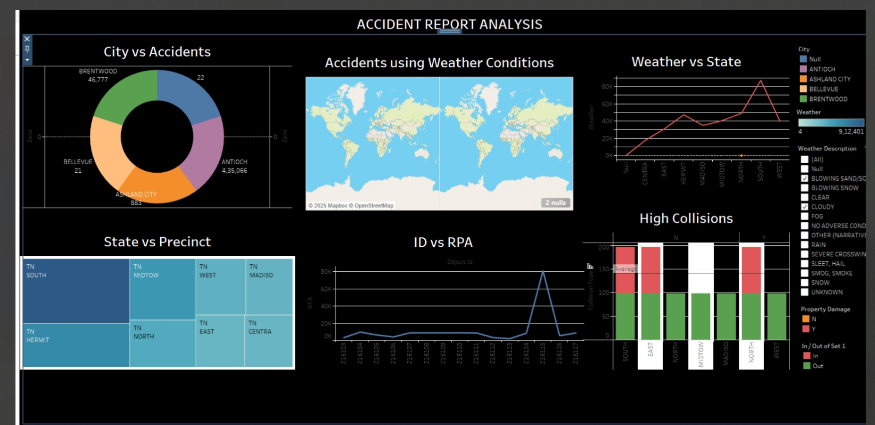

### **Conclusion**

* The Accident Report Analysis conducted using Tableau provides crucial insights into accident patterns across different cities, states, weather conditions, and precincts.
* The city-wise analysis highlights that Antioch experiences a significantly higher number of accidents compared to other regions, indicating the need for targeted safety measures.
* Weather condition mapping suggests that adverse weather, such as rain and fog, substantially influences accident rates, particularly in central and southern precincts.
* State versus precinct analysis shows that precincts like TN SOUTH and TN MIDTOWN are more prone to accidents, signaling a need for localized interventions.
* The ID vs RPA trend analysis also identified abnormal spikes, hinting at potential reporting anomalies or major accident clusters that warrant deeper investigation.
* Lastly, the high collision analysis revealed a consistent pattern of property damage across multiple regions, emphasizing the severity of incidents.